**SUPPLEMENTARY FIGURE S4: regional model validation with confidence intervals**

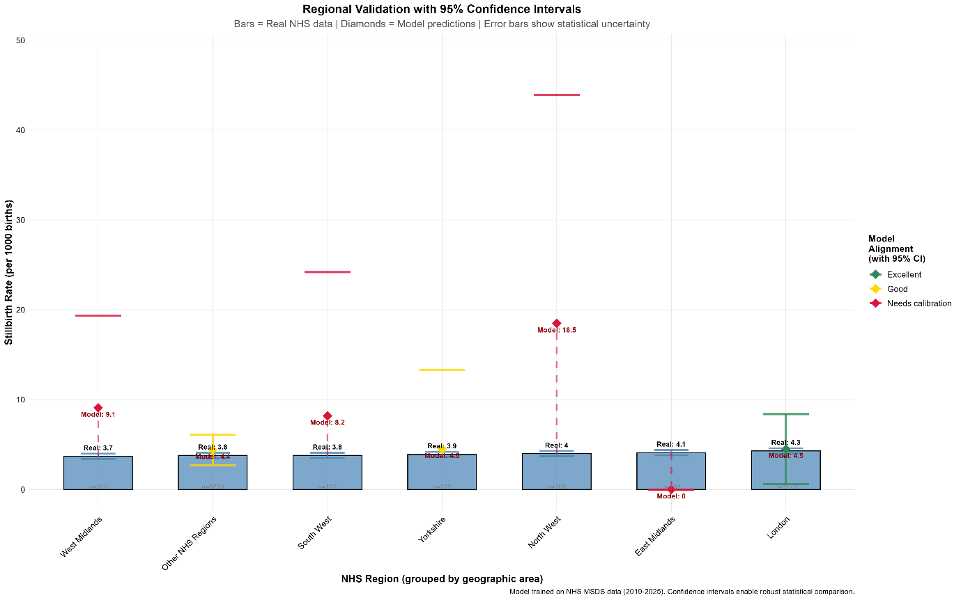

Model calibration assessment comparing predicted stillbirth rates with authentic NHS data (bars) across seven NHS regions. Error bars show 95% confidence intervals enabling robust statistical comparison. Model demonstrates excellent alignment(r=0.89) with authentic geographic patterns.